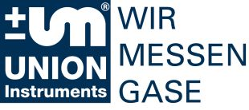
Press release

Making use of digester gas energy
Karlsruhe / Lübeck, February 3, 2016:

Within the framework of the energy transition, digester gases from sewage treatment plants and waste recycling plants are becoming increasingly important. The gas analysis component of the related plant technology plays an important role both for process monitoring and for safeguarding the plant components operated with the digester gas. The INCA gas analyzer technology from UNION Instruments is specially tailored for this.
INCA is a modular multi-component gas analyzer that can be flexibly configured with special orientation to analysis of natural gas as well as biogas and digester gas. It consists of modules for sample gas feed, sample gas conditioning, sensors (using different detection methods), control, and data processing, from which an analysis system tailored to the specific application is configured – for inside or outside installation or operation in hazardous areas. Finally, available options include a measuring gas cooler and an automatic measuring point switchover for up to 10 measuring points.
For analysis of digester gases in particular but also for all other applications, the patented sensors provide robust H2S measurements over a long time period in the concentration range of less than a few ppm to 10,000 ppm.

Captions:

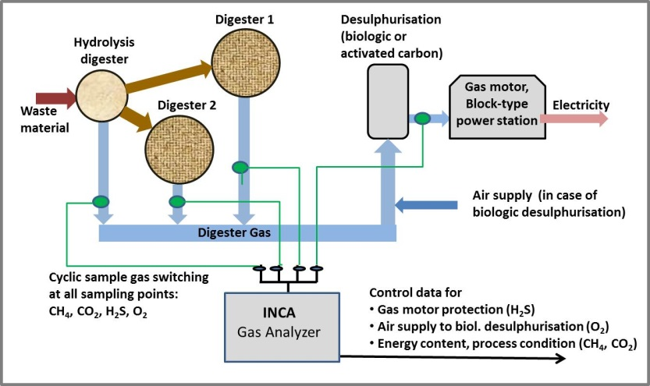

Image 1(UNION-Instruments_PM2016-01_MBA_pic1_Configuration):
Typical gas analysis configuration in a mechanical/biological waste treatment plant with four measuring points for one analyzer

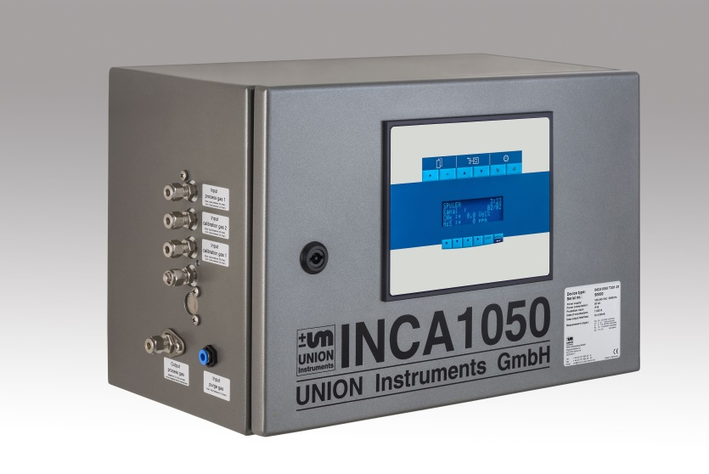

Image 2 (UNION-Instruments_PM2016-01_MBA_pic2_INCA):
The INCA gas analyzers are extremely well-suited for determination of highly fluctuating concentrations of H2S, such as in digester gas.

About UNION Instruments
Founded in 1919 UNION Instruments GmbH is a specialized provider of measurement instruments for calorimetry and gas composition. Its users and customers include the chemical industry, iron and steel industry, energy and water suppliers, glass and ceramic manufacturers, as well as biogas producers. The company has its headquarters in Karlsruhe and a subsidiary in Lübeck. With 20 international distributors, UNION Instruments operates worldwide (for example, in USA, China, Russia, Brazil., Belgium, India, and Southeast Asia.). Its core businesses include development and manufacturing as well as maintenance, service, and support.

Reader contact:
UNION Instruments GmbH
Zeppelinstraße 42
D - 76185 Karlsruhe, Germany
Phone: +49 721 680381 0
Fax: +49 721 680381 33
info@union-instruments.com
www.union-instruments.com

Press contact:
Dr. Oestreich Consulting
Dr. Volker Oestreich
Hans-Baldung-Grien-Weg 9
D - 76149 Karlsruhe, Germany
Phone: +49 721 7880038
Fax: +49 3212 7880038
voe@voe-consulting.de
www.voe-consulting.de

